Lower Mokau – Quarterly River Monitoring
Sample Collection Day: 13th August 2024
Water quality was Fair. Dissolved inorganic nitrogen was slightly elevated and water clarity was low.
E. coli was very low (130) and well within recommended health levels for swimming (540). Nitrate concentrations were well below ecological toxicity impacts (2.4 mg/L). Ammonia concentrations were low, falling well below ecological toxicity impacts (0.24 mg/L) Dissolved inorganic nitrogen (DIN) was slightly elevated (0.67 mg/L), potentially impacting ecological health. DIN concentrations greater than 0.5 mg/L can cause ecological impacts like excessive growth of algae and aquatic plants, and loss of sensitive species. Dissolved reactive phosphorus was exceptionally low (0.005 mg/L). Water clarity was poor (1.15 m), relative to the national bottom line (1.34 m).
Mokau River – Summary of water quality collected at 15 sites across the Mokau River catchment on 13th August 2024
E. coli, ammonia and dissolved reactive phosphorus were low at most sites. The key contaminants were suspended sediment and nitrate.
E. coli: 73% of all sites had low concentrations (≤210), while 27% (4 sites) had slightly elevated concentrations (between 310 to 410). Nitrate and Ammonia: 100% of sites were well below toxicity levels. Nitrate range (0.2 – 0.92 mg/L); Ammonia range (<0.005 - 0.03). Dissolved inorganic nitrogen (DIN): 53% of sites had low concentrations (≤0.47 mg/L) and 47% fell above the ecological impact threshold of 0.5 mg/L. The highest DIN concentration was 0.93 mg/L. Dissolved reactive phosphorus: 93% of sites had low concentrations (between <0.002 to 0.009 mg/L), 7% (1 site) had slightly elevated concentrations 0.012 mg/L. Water clarity: 27% (4 sites) had good water clarity (A or B band), 7% (1 site) had reduced water clarity (C band) and the remaining 67% had poor water clarity (D band). Bands for each site relate to the national bottom line (NBL) for water clarity and are dependent on landscape characteristics including geology, climate and elevation. The NBL for Mokau River’s monitoring sites are either 1.34 m or 0.61 m, dependant on the local landscape characteristics.

River Level and Flow Rate – Mokau River, Totoro Road

The below charts present continuous data collected by the Waikato Regional Council for Mokau River between 1st January and 31st August 2024. River Level and Flow Rate on the day of sampling (13-August) are highlighted on the second chart.
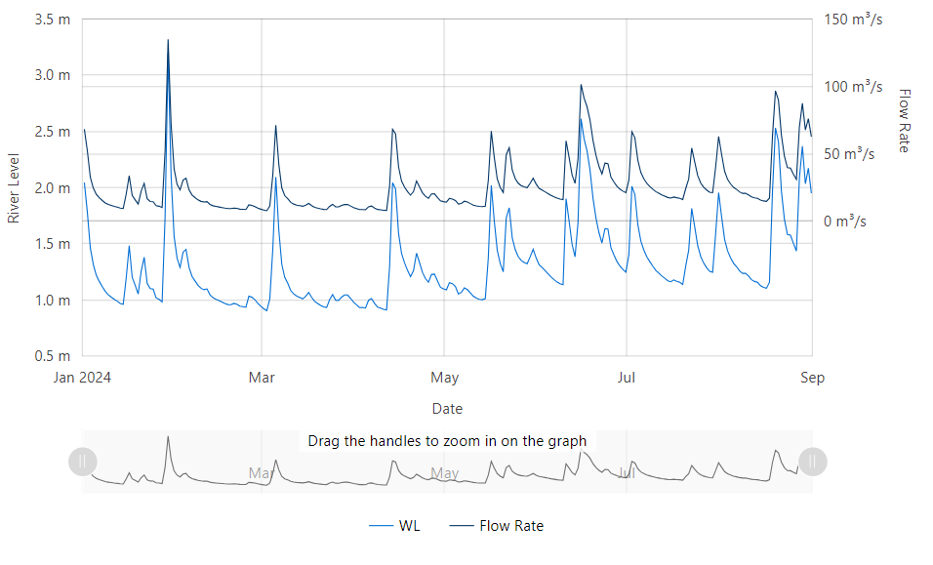

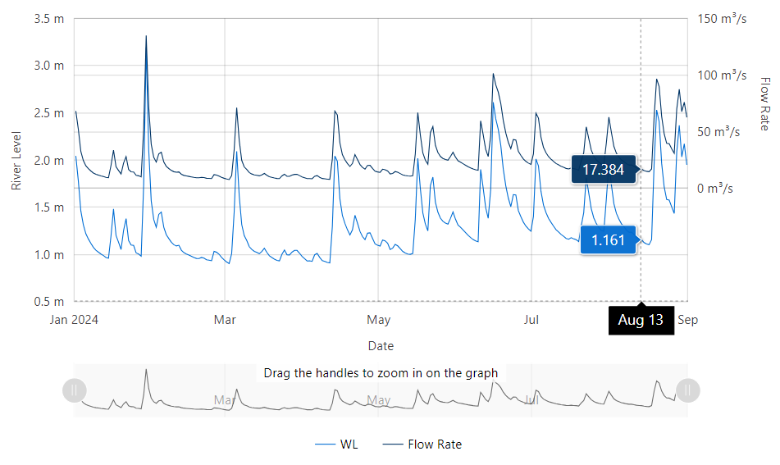
Data source: Waikato Regional Council envirohub website for environmental data.

